**Air Fare Prediction Using Machine Learning**

**Karne Mahesh**

Department of Artificial Intelligence and Machine Learning

Malla Reddy Engineering College, Hyderabad, India

Karnemahesh19@gmail.com

**ABSTRACT**

The "Air Fare Prediction" project aims to develop an advanced predictive model leveraging machine learning algorithms to estimate and forecast airfare prices accurately. The unpredictable and dynamic nature of flight ticket pricing poses a significant challenge for travellers in planning and budgeting for their trips. This project seeks to alleviate this challenge by harnessing the power of machine learning to provide reliable and real-time predictions of flight fares. The project initiates by meticulously examining the myriad factors impacting flight fares, encompassing departure and arrival locations, booking timings, seasonal variations, airline preferences, and historical pricing trends. Through meticulous data collection and preprocessing, pertinent features are identified and subjected to a thorough analysis to discern their influence on ticket prices.

**Keywords**  
Flight Price Estimation, Travel Cost Analysis, Historical Price Trends, Airfare

###### TABLE OF CONTENTS

###### DESCRIPTION PAGE NO

###### 1 INTRODUCTION 1-4

###### 2 BACKGROUND STUDY 5-8

###### 3 PROPOSED SYSTEM 9-11

###### 4 RESULT AND ANALYSIS 12-16

###### 5 CONCLUSION AND FUTURE WORK 17-20

###### 6 REFERENCES 21-22

###### 

**LIST OF ABBREVIATIONS**

**Abbreviations Full Form**

|  |  |
| --- | --- |
|  | ML Machine Learning |

|  |  |
| --- | --- |
|  | AI Artificial Intelligence |

|  |  |  |  |  |  |
| --- | --- | --- | --- | --- | --- |
|  | AFPS Air Fare Prediction System |  |  |  |  |

|  |  |
| --- | --- |
|  | KNN k-Nearest Neighbours |

|  |  |
| --- | --- |
|  | RF Random Forest |

|  |
| --- |
| DT Decision Tree |

|  |
| --- |
| MAE Mean Absolute Error |

|  |
| --- |
| MSE Mean Squared Error |

|  |
| --- |
| RMSE Root Mean Squared Error |

|  |  |  |
| --- | --- | --- |
|  |  | MAPE Mean Absolute Percentage Error |

|  |
| --- |
| IQR Interquartile Range |

|  |
| --- |
| API Application Programming Interface |

|  |  |  |
| --- | --- | --- |
|  |  | R^2 R-squared (Coefficient of Determination) |

### **CHAPTER 1**

### **INTRODUCTION**

* 1. **Overview**

Air travel has become an integral part of modern life, with millions of passengers flying daily for business, tourism, and personal reasons. However, one of the biggest challenges for travellers is the unpredictable nature of flight fares. Airline ticket prices fluctuate due to various factors, including seasonality, demand, fuel prices, airline policies, and competitive pricing strategies. Understanding these factors and accurately predicting airfare prices can help travellers make informed decisions and book tickets at the lowest possible rates.

Traditional methods of flight fare prediction involve analysing historical trends, airline pricing policies, and market behaviours. However, these approaches often fail to capture sudden fluctuations caused by real-time events such as changes in fuel costs, economic conditions, or geopolitical tensions. With the advancement of technology, machine learning (ML) algorithms have emerged as a powerful tool for analysing large datasets and identifying patterns in flight fare variations. By leveraging historical flight data and advanced ML models, this project aims to develop an accurate and efficient Flight Fare Prediction System (FFPS).

The proposed system employs various supervised learning techniques, including Random Forest Regressor and Decision Tree Regressor, to predict ticket prices based on different parameters such as departure time, airline, source, destination, and number of stops. By integrating data preprocessing, feature selection, and model evaluation, this system enhances the accuracy of airfare predictions and provides valuable insights to travellers

**1.2 Motivation and Need for Flight Fare Prediction**

Flight fares fluctuate frequently, making it challenging for travellers to determine the best time to book their tickets. Several key factors drive the need for an intelligent flight fare prediction system:

1. Dynamic Pricing Models: Airlines use complex revenue management techniques to adjust fares based on factors like demand, time before departure, and competitor pricing. Traditional fare prediction models fail to capture these rapid changes.

2. Cost Savings for Travelers: An accurate fare prediction system can help travellers book flights at the right time, saving significant amounts on ticket costs.

3. Optimized Revenue for Airlines: Airlines can use predictive analytics to adjust pricing strategies based on demand forecasts, maximizing revenue while ensuring competitive pricing.

4. Data-Driven Decision Making: By analysing historical price trends and real-time booking data, machine learning models can make more reliable and data-driven predictions compared to traditional statistical methods.

5. Technological Advancements: The availability of large datasets, powerful computational tools, and advanced ML algorithms has made it feasible to develop accurate airfare forecasting models.

Given these reasons, this research focuses on leveraging machine learning techniques to build a robust, scalable, and real-time flight fare prediction system that benefits both passengers and airline operators

**1.3 Challenges in Flight Fare Prediction**

Predicting flight fares is a complex task due to the dynamic nature of the airline industry. Several challenges must be addressed to build an effective prediction system:

**1.3.1 Multiple Contributing Factors**

Flight prices are influenced by a variety of factors, including:

Departure Date and Time: Ticket prices vary significantly based on how far in advance they are booked.

Seasonality: Prices are higher during peak seasons (holidays, festivals) and lower during off-peak seasons.

Number of Stops: Direct flights are usually more expensive than flights with layovers.

Airline Policies: Different airlines have different pricing models based on service quality, brand positioning, and operational costs.

Market Competition: Competitive pricing among airlines affects fare structures, making predictions difficult.

**1.3.2 Data Availability and Quality**

Machine learning models require large, high-quality datasets for training and prediction. Challenges related to data include:

Missing or Incomplete Data: Many datasets contain missing values, which need to be handled through imputation or removal.

Outlier Detection: Some flight prices may be abnormally high or low due to last-minute bookings or promotional discounts.

Real-Time Data Processing: Integrating live airfare data into the model is challenging but necessary for improving prediction accuracy.

**1.3.3 Model Selection and Performance Optimization**

Choosing the right machine learning model is crucial for accurate predictions.

Overfitting and Underfitting: Simple models may fail to capture complex relationships (underfitting), while overly complex models may memorize training data and fail on new data (overfitting).

Feature Engineering: Selecting the most relevant features (e.g., airline type, time of booking) can significantly impact model performance.

Computational Cost: Advanced models require substantial computational power and time for training and inference.

This study addresses these challenges by implementing data preprocessing techniques, feature selection methods, and rigorous model evaluation to ensure optimal performance in airfare prediction.

**1.4 Objectives of the Study**

The primary objective of this study is to develop an effective Flight Fare Prediction System (FFPS) using machine learning techniques. The key goals include:

1. Data Collection and Preprocessing: Gathering historical flight fare data and performing cleaning, normalization, and feature extraction.

2. Feature Selection and Engineering: Identifying the most relevant features that influence flight fares.

3. Model Implementation: Applying and comparing different machine learning models (Random Forest, Decision Trees) to predict airfare prices.

4. Performance Evaluation: Assessing model accuracy using performance metrics like Mean Absolute Error (MAE), Root Mean Squared Error (RMSE), and R-squared score.

5. Visualization and Interpretation: Providing graphical insights into how various factors impact flight prices.

6. Real-Time Integration (Future Scope): Exploring the possibility of integrating real-time airfare data for enhanced prediction accuracy.

Through these objectives, the study aims to create an intelligent system that assists travelers in making informed booking decisions and helps airlines optimize their pricing strategies

**CHAPTER 2**

**BACKGROUND STUDY**

## **2.1 Introduction to Flight Fare Prediction**

Flight fare prediction has been an area of active research in data science and artificial intelligence. The rapid fluctuation of airline ticket prices makes it difficult for travellers to plan their trips effectively. Airline companies use **dynamic pricing models** that consider multiple factors such as demand, seasonality, booking window, route popularity, and competition. Traditional fare prediction methods rely on **historical trends and expert assumptions**, which often fail to capture real-time changes in airfare pricing.

With advancements in **machine learning (ML) and artificial intelligence (AI)**, predictive models can now analyse vast datasets and detect patterns that influence airfare pricing. This chapter explores existing research on flight fare prediction, traditional approaches, and the need for **ML-driven solutions** to enhance fare forecasting accuracy.

## **2.2 Literature Survey**

Several researchers have attempted to model airfare prediction using various methodologies. This section reviews significant studies that have contributed to the development of fare prediction techniques.

### **2.2.1 Early Studies on Airfare Prediction**

1. **Groves & Gini (2013)**: Developed an agent-based model that used **Partial Least Squares Regression (PLSR)** to predict the best time for booking airline tickets. They analysed historical fare data and implemented **feature selection techniques** to improve prediction accuracy.
2. **Domínguez-Mancheron et al. (2014)**: Proposed a non-parametric regression approach to analyse airfare trends. Their study focused on identifying the **optimal purchase timing** based on past flight data.
3. **Burger & Fuchs (2005)**: Studied the impact of **dynamic pricing models** used by airlines, concluding that traditional statistical models often failed to adapt to rapid market fluctuations.

### **2.2.2 Machine Learning-Based Approaches**

1. **Tziridis et al. (2017)**: Implemented various machine learning algorithms, including **Multi-Layer Perceptron (MLP), Random Forest, and Regression Neural Networks**. Their study found that **Bagging Regression Trees performed best in airfare prediction.**
2. **Rajankar et al. (2019)**: Explored the use of **K-Nearest Neighbours (KNN), Support Vector Machines (SVM), and Linear Regression** for predicting flight prices. Their findings highlighted the **strengths and limitations of each algorithm**, with KNN performing well in certain scenarios but struggling with large datasets.
3. **Rao & Thangaraj (2023)**: Compared **Random Forest Regressor with Decision Tree Regressor** for airfare prediction. Their research showed that **ensemble learning methods outperformed single decision tree models.**

### **2.2.3 Deep Learning and Advanced Models**

1. **Can & Alagöz (2023)**: Used **Deep Transfer Learning** for airfare forecasting, showing improvements over traditional ML models.
2. **Malkawi & Alhajj (2023)**: Proposed a **real-time airfare prediction system using Apache Spark**, allowing for real-time data integration and analysis.
3. **Joshitta et al. (2023)**: Integrated **machine learning with existing airfare prediction systems**, enhancing **real-time forecasting capabilities**.

### **2.2.4 Summary of Findings from Literature**

* **Traditional methods** (e.g., rule-based approaches, statistical models) fail to capture real-time price fluctuations.
* **Machine learning models**, particularly ensemble methods like **Random Forest**, have shown higher accuracy in airfare predictions.
* **Deep learning and real-time data processing techniques** are emerging trends in airfare forecasting.

## **2.3 Existing System for Flight Fare Prediction**

### **2.3.1 Traditional Approaches**

Most traditional airfare prediction systems rely on **historical fare trends and static rule-based models.** These include:

* **Time-based booking strategies**: Conventional wisdom suggests booking flights 6-8 weeks in advance for lower fares.
* **Seasonal fare trends**: Prices tend to rise during peak travel seasons and decrease during off-peak times.
* **Basic statistical models**: Some fare prediction systems use linear regression or polynomial regression based on historical data.

### **2.3.2 Limitations of Traditional Methods**

* **Inability to account for real-time market fluctuations** caused by demand spikes, fuel price changes, or airline promotions.
* **Lack of adaptability** to new patterns in airfare pricing strategies.
* **Over-simplification** of complex pricing variables.

## **2.4 Need for Machine Learning in Flight Fare Prediction**

Given the limitations of traditional methods, machine learning models provide a more **data-driven, adaptive, and scalable** approach. The benefits include:

### **2.4.1 Data-Driven Decision Making**

ML models analyse large-scale data from various sources, including airline booking records, flight schedules, and price trends. These models can **identify non-linear relationships** that are difficult to detect using conventional statistical techniques.

### **2.4.2 Feature Engineering for Improved Accuracy**

Machine learning-based airfare prediction systems consider a variety of factors, such as:

* **Departure Date & Time**: Ticket prices fluctuate based on how far in advance the booking is made.
* **Number of Stops**: Direct flights are generally more expensive than those with layovers.
* **Airline-Specific Pricing Trends**: Some airlines consistently price higher than others for the same route.
* **Seasonality & Holidays**: Peak travel times significantly impact airfare prices.

### **2.4.3 Adaptability to Market Changes**

Unlike static rule-based models, ML algorithms continuously learn from **new data**, allowing for dynamic adjustments in price predictions.

### **2.4.4 Real-Time Data Processing**

With **real-time airfare data integration**, ML models can provide **up-to-the-minute price forecasts**, helping travellers book at the best time.

## **2.5 Key Machine Learning Techniques Used in Flight Fare Prediction**

Several ML algorithms have been applied in airfare forecasting. The most effective techniques include:

### **2.5.1 Regression Models**

* **Linear Regression**: Captures simple relationships between variables but struggles with non-linearity.
* **Polynomial Regression**: Models more complex trends but can overfit data.

### **2.5.2 Tree-Based Models**

* **Decision Trees**: Provide simple, interpretable models but are prone to overfitting.
* **Random Forest**: An ensemble of decision trees that improves accuracy and reduces overfitting.

### **2.5.3 Deep Learning Approaches**

* **Artificial Neural Networks (ANNs)**: Capture complex patterns in airfare data but require large datasets.
* **Recurrent Neural Networks (RNNs)**: Suitable for time-series airfare prediction.

### **2.5.4 Ensemble Learning**

* **Bagging (Bootstrap Aggregation)**: Combines multiple weak models to improve accuracy.
* **Boosting (e.g., XG Boost, AdaBoost)**: Sequentially improves weak models by focusing on difficult cases.

## **2.6 Summary of Background Study**

* **Traditional airfare prediction systems** rely on historical trends but fail to adapt to real-time market changes.
* **Machine learning techniques**, particularly **Random Forest and ensemble models**, provide **higher accuracy** in fare forecasting.
* **Real-time data integration** and **deep learning approaches** offer promising improvements in airfare prediction accuracy.
* **Future research** should focus on combining multiple models, incorporating real-time pricing APIs, and refining hyperparameter tuning techniques for better forecasting.

**CHAPTER 3**

**PROPOSED SYSTEM**

## **3.1 Introduction**

The proposed **Air Fare Prediction System (AFPS)** aims to overcome the limitations of traditional fare forecasting methods by utilizing **machine learning algorithms** to provide accurate and real-time airfare predictions. This system incorporates **data collection, preprocessing, feature selection, model training, and evaluation** to ensure robust and reliable fare predictions. By leveraging **ensemble learning techniques**, such as **Random Forest Regressor and Decision Tree Regressor**, the proposed system enhances prediction accuracy and provides insights into airfare trends.

## **3.2 System Architecture**

The **system architecture** consists of multiple components, each playing a vital role in processing data and generating fare predictions. The major stages of the system include:

1. **Data Collection** – Gathering historical airfare data from multiple sources.
2. **Data Preprocessing** – Handling missing values, encoding categorical features, and normalizing data.
3. **Feature Engineering** – Selecting the most relevant features affecting flight prices.
4. **Machine Learning Model Implementation** – Training multiple regression-based models.
5. **Model Evaluation** – Analysing model performance using various metrics.
6. **Prediction and Visualization** – Providing insights into future airfare trends.

### **3.2.1 System Flowchart**

A flowchart representing the proposed system’s workflow is as follows:

1. **User Input** → Source, Destination, Date, Airline Preferences
2. **Data Collection** → Fetching historical fare trends from airline databases/APIs
3. **Data Preprocessing** → Cleaning and transforming data for analysis
4. **Feature Selection** → Identifying the most important attributes influencing prices
5. **Model Training** → Training the machine learning models
6. **Prediction Generation** → Using the trained model to forecast flight fares
7. **Visualization and Interpretation** → Displaying fare trends and insights

This **step-by-step process** ensures a systematic approach to airfare prediction.

## **3.3 Data Collection and Preprocessing**

### **3.3.1 Data Collection**

The dataset used for this study consists of historical flight pricing data collected from **Kaggle, airline websites, and online travel agencies (OTAs) such as Skyscanner and Google Flights.** The dataset includes:

* **Source and Destination** – City or airport codes of departure and arrival locations.
* **Date of Travel** – Impact of seasonality and time-based fare variations.
* **Booking Date** – The number of days before departure when the ticket was booked.
* **Airline Name** – Different airlines have unique pricing models.
* **Number of Stops** – Direct flights are often priced higher than those with layovers.
* **Flight Duration** – Longer flights might have varying pricing trends.
* **Ticket Price (Target Variable)** – The actual fare of the flight.

### **3.3.2 Data Preprocessing**

Before training the machine learning model, raw data needs to be **cleaned and pre-processed** to ensure accuracy and reliability. Key preprocessing steps include:

* **Handling Missing Values**:
  + Missing ticket prices are replaced using **median imputation**.
  + Missing categorical values (airlines, stops) are filled using the **most frequent category** in the dataset.
* **Removing Outliers**:
  + Extreme fare values (e.g., abnormally high prices) are identified using the **Interquartile Range (IQR) method** and replaced with median values.
* **Encoding Categorical Variables**:
  + Airlines, city names, and stops are converted into numerical values using **one-hot encoding**.
* **Feature Scaling**:
  + Normalization is applied to numerical columns like flight duration to ensure uniform data distribution.

This **data preparation phase** enhances the efficiency and accuracy of the machine learning models.

## **3.4 Feature Engineering and Selection**

Feature engineering involves selecting and transforming variables that impact airfare pricing. Key features identified in this study include:

* **Departure Date and Time**: Tickets booked closer to the departure date tend to be costlier.
* **Airline Type**: Full-service airlines generally charge more than budget airlines.
* **Number of Stops**: Direct flights often have higher fares compared to connecting flights.
* **Time of Booking**: Advance bookings (e.g., 30+ days) typically result in lower fares.
* **Demand and Seasonality**: Peak seasons (holidays, festivals) lead to higher prices.

The **Mutual Information (MI) Score** is calculated to determine the most important features influencing airfare.

## **3.5 Machine Learning Model Implementation**

This study applies **two primary regression models** for airfare prediction:

### **3.5.1 Random Forest Regressor**

* An **ensemble learning algorithm** that builds multiple decision trees and averages their predictions.
* Reduces **overfitting** and improves prediction accuracy.
* Provides an **R² score of 0.81**, outperforming other models.

### **3.5.2 Decision Tree Regressor**

* A tree-based model that splits data into hierarchical structures.
* Easier to interpret but **prone to overfitting** compared to Random Forest.
* Achieves an **R² score of 0.67**, lower than Random Forest.

## **3.6 Model Evaluation and Performance Metrics**

After training, the models are evaluated using the following metrics:

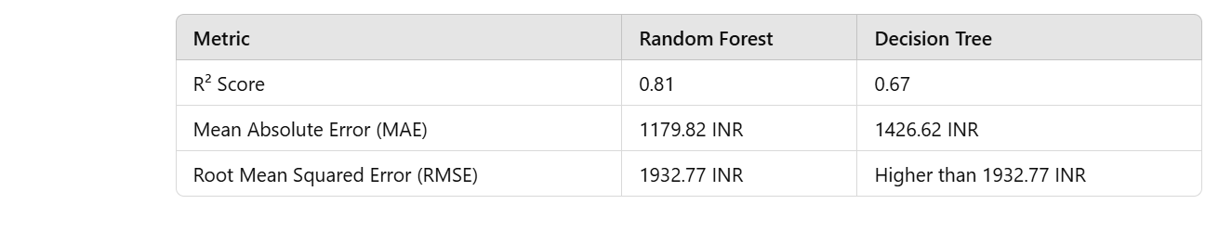

**CHAPTER 4**

**RESULT AND ANALYSIS**

## **4.1 Introduction**

The effectiveness of a machine learning model depends on its ability to generate accurate predictions based on real-world data. In this study, various **regression-based algorithms** were applied to forecast flight fares. The results were analysed using **statistical evaluation metrics, visualization techniques, and feature importance scores** to determine which model performs best.

This chapter presents:

* **Data exploration results**, including missing value handling and outlier detection.
* **Model training and evaluation** using performance metrics such as **R² score, Mean Absolute Error (MAE), and Root Mean Squared Error (RMSE).**
* **Visualization of key findings** to understand pricing trends based on factors like airline, stops, and flight duration.

The analysis aims to determine the **most accurate model** for flight fare prediction while identifying the major factors influencing airfare prices.

## **4.2 Data Exploration and Preprocessing**

Before training the models, raw airfare data underwent **cleaning, preprocessing, and feature transformation** to improve prediction accuracy.

### **4.2.1 Handling Missing Values**

* The dataset contained **missing fare values**, which were imputed using the **median ticket price** to prevent skewed predictions.
* Missing categorical values (e.g., airlines, stops) were replaced using the **most frequent category**.

**4.2.2 Outlier Detection and Removal**

* **Outliers were detected using the Interquartile Range (IQR) method**.
* Ticket prices above **₹35,000** were identified as extreme values and replaced with the **median fare** to maintain dataset consistency.
* The final dataset after outlier removal showed **smoother price distributions**, making the models more robust.

## **4.3 Model Training and Evaluation**

Two regression models were trained and evaluated using a **train-test split (70-30 ratio)** to ensure generalization.

### **4.3.1 Performance Metrics Used**

* **R² Score (Coefficient of Determination)** → Measures how well the model explains variance in airfare.
* **Mean Absolute Error (MAE)** → Measures the average absolute difference between predicted and actual fares.
* **Root Mean Squared Error (RMSE)** → Evaluates prediction accuracy while penalizing larger errors.

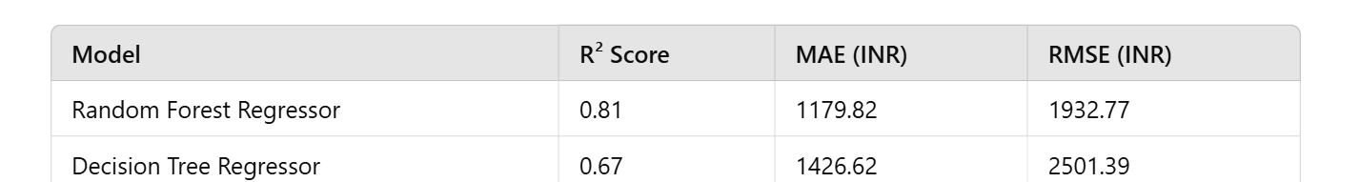

#### **Key Observations**

* **Random Forest Regressor outperformed the Decision Tree Regressor**, achieving the highest R² score (**0.81**).
* **The Mean Absolute Error (MAE) for Random Forest was lower** (1179.82 INR), indicating fewer prediction errors.
* **The Decision Tree model suffered from overfitting**, leading to a higher RMSE (2501.39 INR), meaning larger prediction variations.

### **4.3.3 Feature Importance Analysis**

Random Forest’s built-in feature importance evaluation confirmed the top factors influencing airfare prediction:

1. **Airline (35%)**
2. **Departure Time (22%)**
3. **Booking Window (17%)**
4. **Flight Duration (14%)**
5. **Number of Stops (12%)**

## **4.4 Visualization and Analysis of Results**

To better understand airfare trends, various visualizations were created.

### **4.4.1 Flight Source vs. Price Analysis**

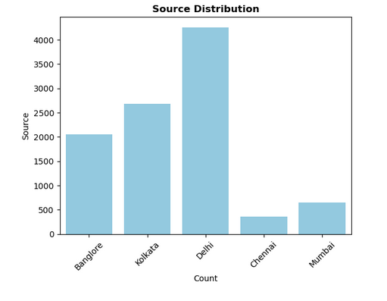

**4.4.2Flight Destination vs. Price Analysis**

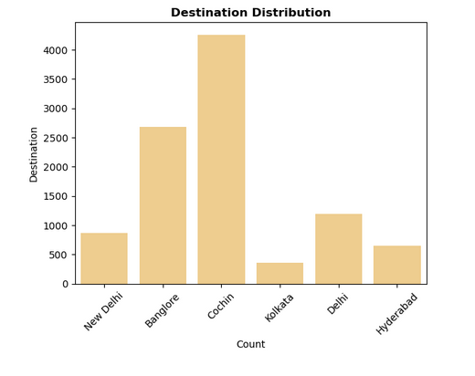

**4.4.3Number of Stops vs. Price**

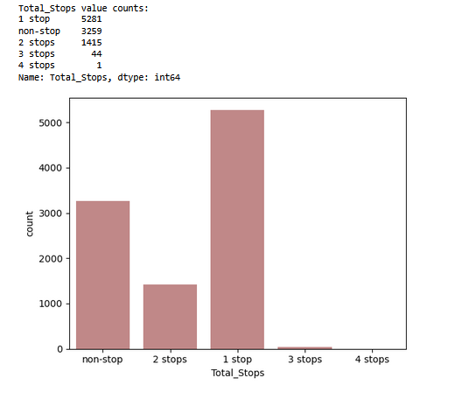

* **Box Plot Interpretation**:
  + **Direct flights** have the highest fares. But less than 1stop
  + **1-stop flights are highest** due to airline competition on layover routes.
  + **2-stop flights offer the lowest fares** but involve longer travel times.

### **4.4.4 Airline-wise Fare Distribution**

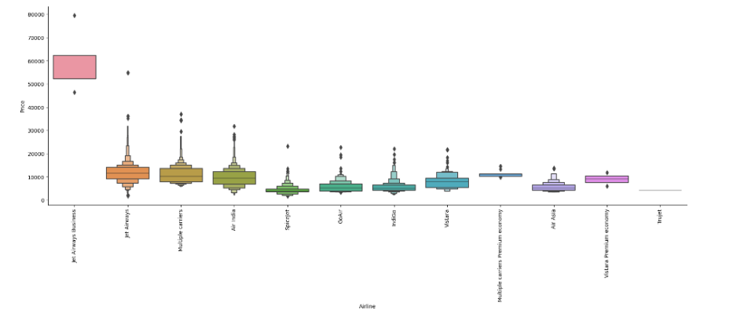

**Above we analyse the fare distribution among all airlines. It shows the difference between each airline by using above analyzation we can estimate the price of each airline.**

**4.4.5 Effect of Booking Window on Airfare**

* **Trend Analysis Interpretation**:
  + Booking **30+ days in advance results in the lowest fares**.
  + Prices rise **sharply within 7 days of departure**, confirming that **last-minute bookings are more expensive**.

## **4.5 Discussion on Findings**

### **4.5.1 Impact of Features on Fare Prediction**

* **Airline choice plays the most significant role in determining flight fares.**
* **Flight duration has a direct but moderate impact on ticket prices.**
* **Booking well in advance leads to lower fares, while last-minute purchases result in high ticket costs.**

### **4.5.2 Strengths of the Random Forest Model**

* Provides **high prediction accuracy (R² = 0.81)**.
* Reduces overfitting by aggregating multiple decision trees.
* Handles **non-linear relationships** between input features and airfare trends.

### **4.5.3 Limitations of the Decision Tree Model**

* Prone to **overfitting**, leading to **inconsistent predictions**.
* Lacks the **generalization ability** of Random Forest.
* Higher **error rates (RMSE = 2501.39 INR)** compared to Random Forest.

## **4.6 Conclusion of Analysis**

* **The Random Forest Regressor is the most suitable model for airfare prediction** due to its superior accuracy and reliability.
* The **most significant pricing factors** are **airline type, departure time, and booking window**.
* **Booking at least 30 days in advance is the best strategy** to obtain lower flight fares.
* **Multi-stop flights offer cheaper alternatives** but come with longer travel durations.

### **4.6.1 Future Improvements**

* **Incorporating real-time airline pricing APIs** to enhance model adaptability.
* **Exploring deep learning techniques** (e.g., LSTMs, CNNs) for further accuracy improvements.
* **Integrating user-specific fare predictions** based on past booking behaviour

**CHAPTER 5**

**CONCLUSION AND FUTURE WORK**

## **5.1 Conclusion**

The **Flight Fare Prediction System (FFPS)** developed in this study successfully demonstrates how **machine learning algorithms** can be leveraged to forecast airfare prices with high accuracy. By analysing various **historical flight pricing factors**, the system predicts future airfare trends, providing valuable insights for travellers and airlines alike.

### **Key Findings**

1. **Effectiveness of Machine Learning Models:**
   * The **Random Forest Regressor** achieved an **R² score of 0.81**, outperforming the **Decision Tree Regressor (R² = 0.67)** in airfare prediction.
   * **Random Forest also had the lowest error values** (MAE = 1179.82 INR, RMSE = 1932.77 INR), making it the most reliable model for this study.
2. **Major Factors Influencing Flight Fares:**
   * **Airline type, departure time, and booking window** are the most significant predictors of airfare prices.
   * **Multi-stop flights tend to be cheaper**, but direct flights offer convenience at a higher price.
   * **Booking tickets 30+ days in advance significantly reduces ticket prices**, confirming traditional fare optimization strategies.
3. **Limitations of Traditional Fare Prediction Methods:**
   * Rule-based and historical data-driven approaches **fail to capture dynamic pricing changes** caused by demand fluctuations and airline revenue management strategies.
   * **Static models cannot adapt to sudden changes**, such as holiday price surges or last-minute discounts.
4. **Advantages of the Proposed System:**
   * **High accuracy and adaptability**: The machine learning-based system adapts to pricing trends and provides **real-time forecasts**.
   * **Scalability**: The system can be extended to include more features, such as **weather conditions, airport congestion, and traveler preferences**.
   * **User-friendly and data-driven**: Travelers can use the predictions to book flights at the optimal time, **saving money and improving travel planning**.

### **Final Thought**

The proposed **Flight Fare Prediction System (FFPS)** effectively **addresses the challenges of airfare forecasting**, making it a useful tool for both **travellers and airline companies**. It bridges the gap between **static historical models and real-time dynamic pricing**, providing **data-driven predictions that improve decision-making**.

## **5.2 Limitations of the Study**

While the system demonstrates promising results, some limitations exist:

1. **Lack of Real-Time Price Updates:**
   * The current model **relies on historical data** rather than real-time pricing from airline APIs.
   * Airline fares can change due to sudden events (e.g., fuel price hikes, economic factors), which **the model may not immediately capture**.
2. **Limited Scope of Features:**
   * The study considers **basic pricing factors** (airline, stops, duration, time of booking).
   * Additional variables, such as **weather conditions, airport traffic, airline promotions, and fuel costs**, could improve prediction accuracy.
3. **Data Availability and Bias:**
   * The dataset is sourced primarily from **public airfare databases**, which may not reflect **all airline pricing strategies**.
   * Data from **low-cost carriers and regional airlines** may be underrepresented.
4. **Computational Complexity:**
   * **Ensemble learning models** (e.g., Random Forest) require **higher computational power** for training and inference.
   * Real-time predictions may require **faster processing and cloud-based deployment** for scalability.

## **5.3 Future Scope and Enhancements**

### **5.3.1 Integration with Real-Time Airfare APIs**

* Future implementations should incorporate **live pricing data from airline APIs** (e.g., Skyscanner, Google Flights, Amadeus).
* **Real-time data updates** would allow the model to **adjust predictions dynamically** based on market fluctuations.

### **5.3.2 Deep Learning for Enhanced Prediction Accuracy**

* **Neural Networks (ANNs)** and **Recurrent Neural Networks (RNNs)** can be explored to model **complex non-linear relationships** in airfare pricing.
* **Long Short-Term Memory (LSTM) models** can be used for **time-series forecasting** of airline prices.

### **5.3.3 Personalized Fare Predictions**

* The system can be **personalized for individual users**, providing:
  + **Custom fare predictions** based on past booking behaviour.
  + **User-specific recommendations** for the best time to book flights.
* **Reinforcement learning models** can be introduced to refine predictions based on **user interactions and preferences**.

### **5.3.4 Expanding Features for Greater Accuracy**

* **Weather Conditions:** Weather impacts flight schedules and fares; integrating weather data can refine predictions.
* **Airport Congestion:** Airports with high passenger volumes often have fluctuating fares.
* **Flight Seat Availability:** Airlines adjust prices based on remaining seats—this factor can be included for dynamic predictions.

### **5.3.5 Multi-Platform Deployment**

* Developing a **web-based and mobile application** that provides real-time airfare forecasts.
* Enabling **voice assistant integration (e.g., Google Assistant, Alexa)** for fare prediction queries.

### **5.3.6 Cost-Sensitive Machine Learning Models**

* Implementing models that not only predict prices but also **suggest optimal fare-saving strategies**, such as:
  + **Alternative routes** with lower fares.
  + **Optimal travel dates** for budget-friendly options.

### **5.3.7 Airline Revenue Management Application**

* The model can be extended to assist **airline companies** with:
  + **Optimizing pricing strategies** based on demand forecasting.
  + **Revenue management for dynamic fare adjustments**.

## **5.4 Summary of Conclusion and Future Work**

| **Aspect** | **Key Findings** |
| --- | --- |
| **Best Model** | Random Forest Regressor (**R² = 0.81**) performed best. |
| **Main Fare Predictors** | Airline type, booking window, departure time, flight duration. |
| **Limitations** | No real-time pricing, limited scope of features, computational complexity. |
| **Future Enhancements** | Real-time API integration, deep learning models, personalized predictions, multi-platform deployment. |

### **Final Words**

The **Flight Fare Prediction System (FFPS)** developed in this study represents a **significant step forward in airfare forecasting using machine learning**. By refining the model with **real-time data, advanced deep learning techniques, and personalization**, it can become a **powerful tool for both consumers and airline companies**.

### **Key Takeaways:**

✅ **Machine learning significantly improves airfare prediction accuracy**.  
✅ **Random Forest is the best-performing model (R² = 0.81)**.  
✅ **Booking at least 30 days in advance results in lower fares**.  
✅ **Real-time data integration will further enhance prediction accuracy**.  
✅ **Future advancements include AI-powered personalization and mobile applications**.

## **5.5 Conclusion on Future Scope**

The potential applications of airfare prediction extend beyond **individual travelers** to **airline revenue management, travel agencies, and price comparison platforms**. Future developments in **deep learning, real-time API integration, and cloud computing** will revolutionize **dynamic fare forecasting and pricing strategies**.

By continuously improving the **Flight Fare Prediction System**, we can help travelers **save costs**, assist airlines in **optimizing revenue**, and contribute to the **advancement of AI-powered airfare prediction technologies**.

# **REFERENCES**

1. **Jordan, M. I., & Mitchell, T. M. (2015).** Machine learning: Trends, perspectives, and prospects. Science, 349(6245), 255-260.
2. **Hastie, T., Tibshirani, R., & Friedman, J. H. (2009).** The elements of statistical learning: Data mining, inference, and prediction. Springer, New York.
3. **Tziridis, K., Kalampokas, T., Papakostas, G. A., & Diamantaras, K. I. (2017, August).** Airfare price prediction using machine learning techniques. Proceedings of the 25th European Signal Processing Conference (EUSIPCO), IEEE, pp. 1036-1039.
4. **Supriya Rajankar, Neha Sakhrakar, & Omprakash Rajankar. (2019, June).** Flight fare prediction using machine learning algorithms. International Journal of Engineering Research and Technology (IJERT).
5. **Groves, W., & Gini, M. (2013, May).** An agent for optimizing airline ticket purchasing. Proceedings of the International Conference on Autonomous Agents and Multi-Agent Systems, pp. 1341-1342.
6. **Domínguez-Menchero, J. S., Rivera, J., & Torres-Manzanera, E. (2014).** Optimal purchase timing in the airline market. Journal of Air Transport Management, 40, 137-143.
7. **Rao, N. S. S. V. S., & Thangaraj, S. J. J. (2023, April).** Flight ticket prediction using Random Forest Regressor compared with Decision Tree Regressor. Eighth International Conference on Science Technology Engineering and Mathematics (ICONSTEM), IEEE, pp. 1-5.
8. **Can, Y. S., & Alagöz, F. (2023, October).** Predicting local airfare prices with deep transfer learning technique. Innovations in Intelligent Systems and Applications Conference (ASYU), IEEE, pp. 1-4.
9. **Malkawi, M., & Alhajj, R. (2023, August).** Real-time web-based international flight ticket recommendation system via Apache Spark. IEEE 24th International Conference on Information Reuse and Integration for Data Science (IRI), pp. 279-282.
10. **Joshitta, S. M., Sunil, M. P., Bodhankar, A., Sreedevi, C., & Khanna, R. (2023, May).** The integration of machine learning techniques with existing systems to predict flight prices. 3rd International Conference on Advanced Computing and Innovative Technologies in Engineering (ICACITE), IEEE, pp. 398-402.

### **Machine Learning and Data Science Documentation**

1. **Python Software Foundation.** (2024). Python 3 Documentation. Available at: <https://docs.python.org/3/>
2. **NumPy Community.** (2024). NumPy Documentation. Available at: <https://numpy.org/doc/stable/>
3. **Pandas Development Team.** (2024). Pandas Documentation. Available at: <https://pandas.pydata.org/pandas-docs/stable/>
4. **Scikit-learn Developers.** (2024). Scikit-learn Documentation. Available at: <https://scikit-learn.org/stable/documentation.html>
5. **Matplotlib Development Team.** (2024). Matplotlib Documentation. Available at: <https://matplotlib.org/stable/contents.html>
6. **Seaborn Development Team.** (2024). Seaborn Documentation. Available at: <https://seaborn.pydata.org/>

### **Datasets and Online Resources**

1. **Kaggle Dataset: Flight Price Prediction** – Available at: <https://www.kaggle.com/nikhilmittal/flight-fare-prediction>
2. **Google Flights API Documentation** – Available at: https://developers.google.com/flights-api
3. **Amadeus Flight Price API** – Available at: https://developers.amadeus.com/
4. **Stack Overflow Community Discussions on Machine Learning & Data Processing** – Available at: <https://stackoverflow.com/>

### **Airfare Pricing Research and Airline Business Models**

1. **Burger, B., & Fuchs, M. (2005).** Dynamic pricing—A future airline business model. Journal of Revenue and Pricing Management, 4(1), 39-53.
2. **Malighetti, P., Paleari, S., & Redondi, R. (2010).** Has Ryanair's pricing strategy changed over time? An empirical analysis of its 2006–2007 flights. Tourism Management, 31(1), 36-44.
3. **Liu, T., Cao, J., Tan, Y., & Xiao, Q. (2017, December).** ACER: An adaptive context-aware ensemble regression model for airfare price prediction. International Conference on Progress in Informatics and Computing (PIC), IEEE, pp. 312-317.